Dear Parents,
We are starting book reports in our classroom. Your child will be responsible for 2 book reports each month. Your child will receive a sticker for each book reports that they turn in and it will be placed on their individual “book” that is displayed in the classroom. At the end of the month, if they have done both book reports they will get to choose a prize from the treasure box.
When you are helping them with the book report, be sure to talk about the characters, setting, problem/solution, connection, main ideas, author, and illustrator. They will also need to be able to retell the story to you. If they are unable to retell the majority of the book, have them read it again. Make sure they are using “good fit” books for these book reports.
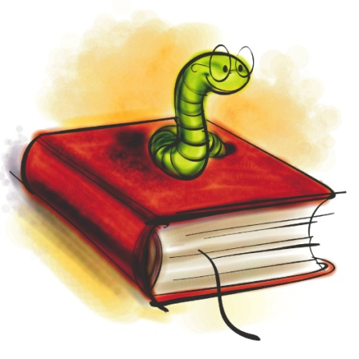
Each quarter your child will be bringing home a tic-tac-toe chart. They will choose 2 squares from this chart to complete each month. Some squares on the chart require a special worksheet or writing paper, so please visit the classroom website to print these documents.
Thank you for helping your child learn the skills to be a great reader!
Mrs. Donohue
*If you need me to print any handouts for you please let me know.*

